HERO STEELS LIMITED
Cold Rolling Steel Plant · Digital Transformation Initiative

MODULE M1 — DATA CAPTURE LAYER
M1-05 · Document 6 of 10
Role-Based Access Control & Security
Roles, line-scoping, the full permission matrix and the access-control architecture
Document set — M1 Technical Blueprint
Doc | Title
M1-00 | Blueprint Overview & Index
M1-01 | System Architecture
M1-02 | Process-Wise Data Capture Design
M1-03 | UX Design & Operator Workflow
M1-04 | Data Model & Database Design
M1-05 | Role-Based Access Control & Security
M1-06 | Planning Integration & Export
M1-07 | Validation Framework
M1-08 | Audit Trail & Compliance
M1-09 | Reporting & Monitoring
Prepared for Z Company · Role: Manufacturing Digital Transformation Consultant / Industrial Software Architect
Version 1.0 · 30 May 2026 · Confidential

Contents

1. Access Model Overview
M1 access is governed by two independent dimensions: role (what kind of action a user may take) and line scope (which processes/lines their actions apply to). A user's effective permission is the intersection of the two. This separation lets the plant grant, for example, Supervisor actions on three specific lines without granting them everywhere — and it is enforced in the data layer so every API inherits it automatically.
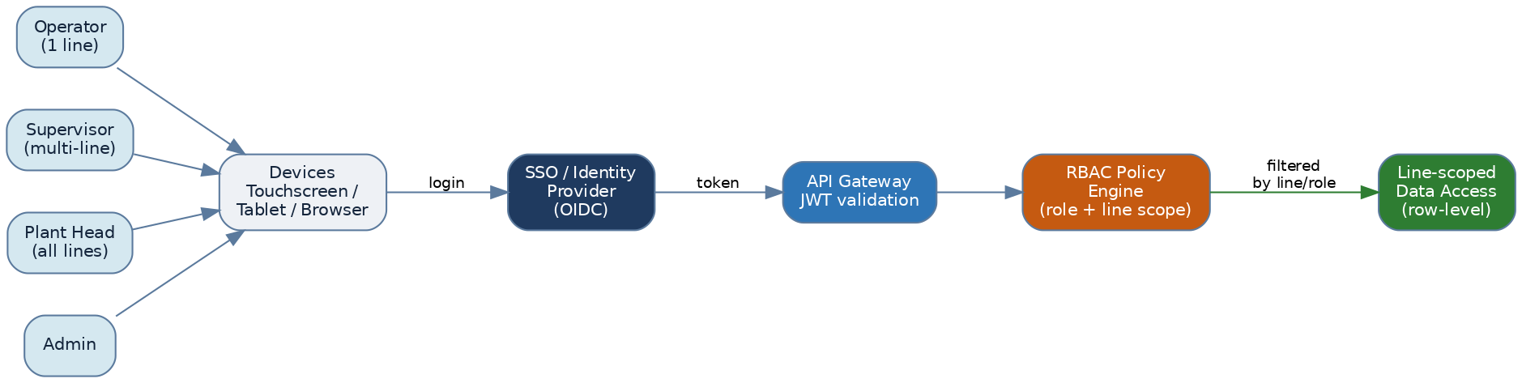
Figure. Authentication, role resolution and line-scoped data access

2. Roles

2.1 Operator
The shop-floor user who captures data. Scoped to a single assigned production line and the current shift.
- Can access only the assigned production line — other lines are invisible, not merely read-only.
- Can enter and edit shift data for the current shift (own draft entries).
- Cannot modify master data (customers, grades, codes) — only select from it.
- Can raise a correction request on locked data, but cannot approve it.
- Sees only own-line dashboards and coil traceability within scope.

2.2 Supervisor
Reviews and is accountable for the data quality of the lines they own.
- Access to multiple lines (their assigned set).
- Reviews operator entries; approves/locks shift logs.
- Approves corrections to locked data, with a recorded reason.
- Monitors shift performance; can override a validation block with a logged justification.
- Views reports and exports within scope.

2.3 Plant Head
Plant-wide visibility for oversight and decision-making — read and analyse, not capture.
- Access to all lines (read-only on transactional data).
- Views dashboards and production / quality / downtime / traceability analytics (M1-09).
- Can export and drill down anywhere; does not capture or approve operational entries.

2.4 Admin
Configures and maintains the system; the only role that touches master data and integration.
- User management and role management (assign roles and line scope).
- Master data management (customers, grades, defect & stoppage codes, operators, furnaces, specs).
- SAP / CSV integration management (connections, mappings, schedules).
- Workflow configuration (validation thresholds, approval rules) and audit controls.
- Does not routinely capture production data; all admin actions are audit-logged.

3. Permission Matrix
Capabilities by role. Y = allowed; R/Own/Multi/All = allowed within that data scope; Config = governed by an Admin-set workflow rule; — = not permitted.
Capability | Operator | Supervisor | Plant Head | Admin
Log in (SSO / badge+PIN) | Y | Y | Y | Y
View own assigned line | Y | Y | Y | Y
View other / all lines | — | Multi | All | All
Create / edit shift data (own line, current shift) | Y | Y | — | —
Edit submitted data (pre-approval) | Own | Y | — | —
Submit shift log | Y | Y | — | —
Approve / lock shift log | — | Y | — | —
Approve correction (post-lock) | — | Y | — | Config
Raise correction request | Y | Y | — | —
Override validation (with reason) | — | Y | — | Y
View dashboards & analytics | Own | Multi | All | All
Coil traceability search | Own | Y | Y | Y
Export data (temp feature) | — | Y | Y | Y
Manage master data | — | — | — | Y
Manage users & roles | — | — | — | Y
Configure SAP / CSV integration | — | — | — | Y
Configure validation / workflow | — | — | — | Y
View audit trail | — | Own scope | All | All

4. Line-Scoping (row-level security)
Line scope is data held in security.line_access(user_id, process_id, access_level). Every query for transactional data is filtered by the caller's accessible processes at the data layer (PostgreSQL row-level security / enforced in the data-access layer). Because the filter is applied server-side, an operator cannot reach another line's data through any route — UI, API or export.
access_level | Meaning
READ | May view entries for the line (e.g. Plant Head, or a cross-trained operator)
WRITE | May create/edit draft entries for the line (Operator on assigned line)
APPROVE | May approve/lock and approve corrections for the line (Supervisor)

5. Authentication & Session Security
- SSO via OIDC against the plant identity provider; badge + PIN fallback for shared shop-floor terminals.
- Short-lived JWT access tokens validated at the API gateway; refresh handled transparently by the PWA.
- Shared-terminal sessions auto-lock after inactivity; the next operator badges in without losing queued work.
- Optional MFA for Admin and remote (management) access.
- All traffic over TLS; service-to-service calls use least-privilege service accounts.

6. Security Controls Summary
Control | Implementation
Least privilege | Role × line-scope intersection; default deny
Separation of duties | Operators capture, Supervisors approve, Admins configure — never the same action
Auditability | Every create/update/delete and every login/export logged immutably (M1-08)
Override governance | Validation overrides require a reason and are restricted to Supervisor/Admin
Master-data protection | Only Admin writes masters; all forms read them
Data-in-transit / at-rest | TLS everywhere; encryption at rest on DB and object store
Account lifecycle | Joiners/movers/leavers via Admin; disabled accounts retain their audit history

Enforcement principle
Permissions are enforced on the server, never only in the UI. Hiding a button is a convenience; the API and the row-level filter are the real control.

